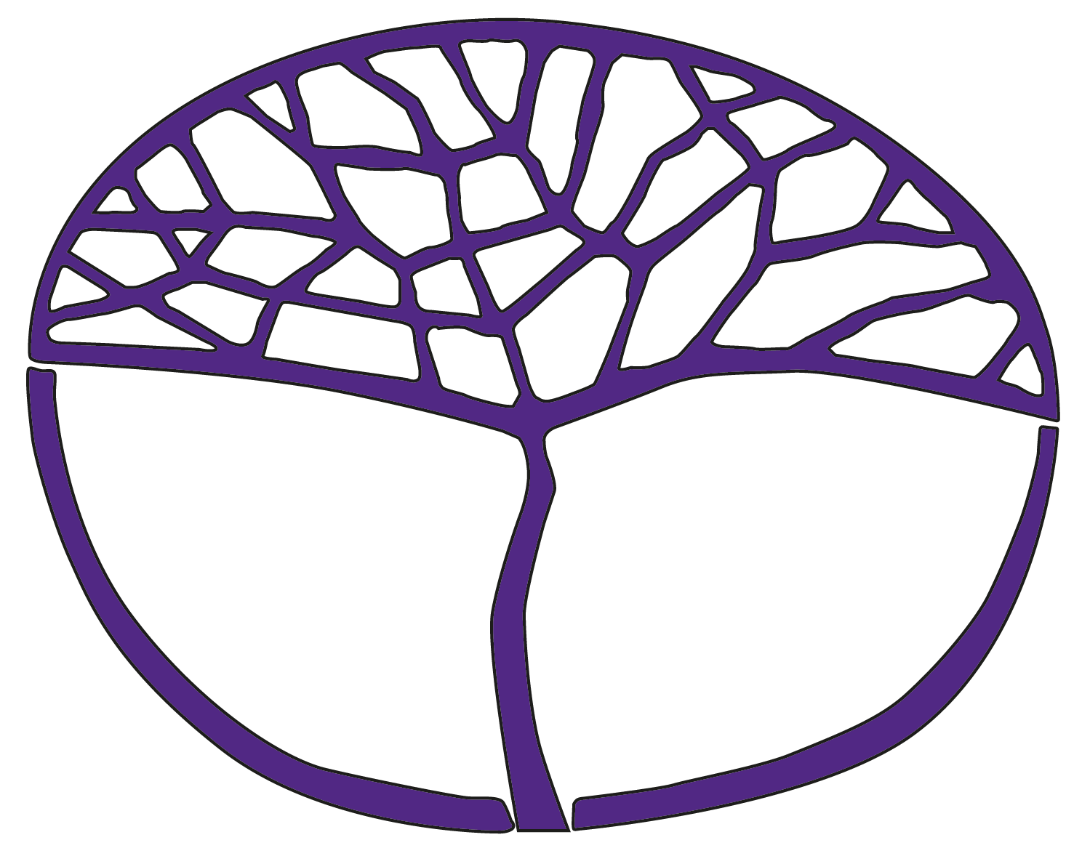**Sample Course Outline**

Integrated Science

General Year 11

**Copyright**

© School Curriculum and Standards Authority, 2014

This document – apart from any third party copyright material contained in it – may be freely copied, or communicated on an intranet, for non-commercial purposes in educational institutions, provided that the School Curriculum and Standards Authority is acknowledged as the copyright owner, and that the Authority’s moral rights are not infringed.

Copying or communication for any other purpose can be done only within the terms of the *Copyright Act 1968* or with prior written permission of the School Curriculum and Standards Authority. Copying or communication of any third party copyright material can be done only within the terms of the *Copyright Act 1968* or with permission of the copyright owners.

Any content in this document that has been derived from the Australian Curriculum may be used under the terms of the [Creative Commons Attribution-NonCommercial 3.0 Australia licence](http://creativecommons.org/licenses/by-nc/3.0/au/)

**Disclaimer**

Any resources such as texts, websites and so on that may be referred to in this document are provided as examples of resources that teachers can use to support their learning programs. Their inclusion does not imply that they are mandatory or that they are the only resources relevant to the course.

# Sample course outline

# Integrated Science – General Year 11

## Unit 1

#### Semester 1 – Marine Biology

| **Week** | **Key teaching points** |
| --- | --- |
| 1 | **Oceanography**   * Characteristics of different marine ecosystems – seagrass meadows, reefs, estuaries, mangroves, deep sea   **Task 1:** Research assignment – marine ecosystems |
| 2–3 | * Water cycle, oxygen-carbon cycle and nitrogen cycle * Methods of measuring abiotic and biotic factors   **Task 2:** Practical–Abiotic and biotic measurement techniques |
| 4–7 | * Cycling of matter in marine ecosystems * Marine food chains and webs in various ecosystems * Biological productivity in various ecosystems   **Task 3:** Investigation – Monitoring a local marine ecosystem |
| 8–9 | * Biology of marine invertebrates * Biology of marine vertebrates * Adaptations to suit marine environments   **Task 4:** Practical –Fish dissection  **Task 5:** Test –Properties of water and marine biology |
| 10–11 | * Factors that create ocean currents * Factors affecting ocean currents * Coastal erosion   **Task 6:** Research assignment –Ocean currents |
| 12–13 | **Management of marine resources**   * Importance of management of marine ecosystems and resources * Strategies for protecting the marine environment |
| 14–15 | * Fisheries management * Aquaculture |
| 16 | * Impact of humans on marine ecosystems   **Task 7:** Test–Fisheries management and human impact |

#### Semester 2 – Rocketry

| **Week** | **Key teaching points** |
| --- | --- |
| 1 | Introduction to rockets |
| 2 | Significance of space exploration  Rocket history  **Task 8:** Research assignment –Rockets timeline |
| 3–5 | Rocket design – aeronautic principles  Types of rockets  **Task 9:** Practical – Bottle rockets  **Task 10:** Investigating –Rocket design |
| 6–9 | Newton’s laws  Gravity  Forces during flight  **Task 11:** Test–Motion, gravity and forces test |
| 10–11 | Fuels used in rockets – solid, liquid, hybrid  Combustion reactions |
| 12–14 | Model rockets  Work, force and energy – model rockets and their solid fuel engines  **Task 12:** Investigation–Factors affecting flight |
| 15 | Uses of rockets  Effect of G-forces on humans  **Task 13:** Research assignment –Humans in space |
| 16 | Space travel  **Task 14:** Test – Rocketry |